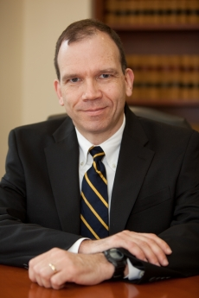

**Professor Gregory E. Maggs**

**George Washington University Law School**

Gregory E. Maggs joined the George Washington University Law School faculty in 1993. He is a Co-director of the law school’s National Security and U.S. Foreign Relations LLM program. He was the Interim Dean of the law school from 2010-2011 and from 2013-2014 and the Senior Associate Dean for Academic Affairs from 2008-2010. He teaches mainly in the areas of commercial law, constitutional law, contracts, and counter-terrorism law, and he has written extensively on these subjects. By vote of the graduating class, he received the law school’s Distinguished Faculty Service Award in 1997, 1998, 2004, 2005, 2011, 2012, 2013, 2014, and 2015. In 2012, the university gave him the George Washington Award for outstanding service.  
  
Professor Maggs is a graduate of Harvard College and Harvard Law School. He was a law clerk for Justices Clarence Thomas (1991-1992) and Anthony M. Kennedy (1989-1990) of the U.S. Supreme Court and for the late Judge Joseph T. Sneed of the U.S. Court of Appeals for the Ninth Circuit (1988-1989). He also taught for two years as an assistant professor at the University of Texas School of Law. His other past experience includes service as a special master for the U.S. Supreme Court, a consultant to Independent Counsel Kenneth Starr in the Whitewater Investigation, and an assistant to Robert H. Bork in private practice and research. He is a member of the Advisory Board for the Heritage Foundation's Center for Legal and Judicial Studies and a member of the American Law Institute.  
  
Professor Maggs is a colonel in the U.S. Army Reserve, Judge Advocate General’s Corps. He was commissioned in 1990, and has been assigned as a trial or appellate military judge since 2007. He is a graduate of the U.S. Army War College, the Military Judge Course, the Command and General Staff Officer Course, the Judge Advocate Officer Advanced and Basic Courses, the Air Assault School, and the Infantry Weapons Specialist Course. He was called to active duty in 2007-2008. In 2002, he received the Judge Advocates Association's Outstanding Career Armed Services Attorney Award.

**Education**

AB, JD, Harvard University; MSS, U.S. Army War College