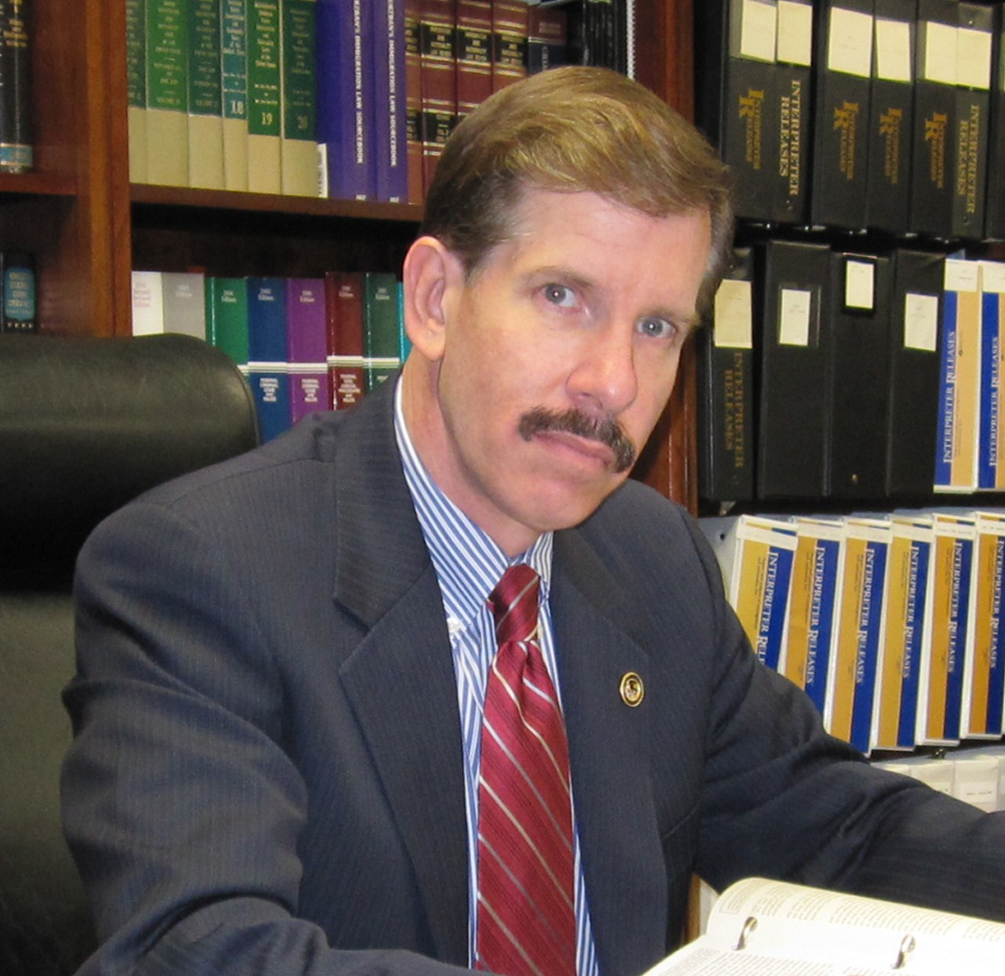
ELI M. ROSENBAUM

Director, Human Rights Enforcement Strategy and Policy
Human Rights and Special Prosecutions Section
Criminal Division, United States Department of Justice

Eli Rosenbaum is the longest-serving prosecutor and investigator of Nazi criminals and other perpetrators of human rights violations in world history, having worked on these cases at the U.S. Department of Justice for some thirty years. A graduate of the Wharton School of the University of Pennsylvania (B.S. and MBA, Finance) and of the Harvard Law School, he served from 1994 to 2010 as Director of the Justice Department's Office of Special Investigations (OSI), where he had previously served as a trial attorney and then as Deputy Director. OSI was created by Attorney General order to investigate and prosecute WWII-era Nazi criminals and, following the December 2004 expansion of its mission by the Intelligence Reform and Terrorism Prevention Act of 2004, also investigated and prosecuted criminal and civil cases involving participants in post-World War II crimes of genocide, extrajudicial killing and torture committed abroad under color of foreign law. Under his leadership, OSI also performed crucial work for the federal government’s inter-agency efforts to trace gold, artwork and other assets looted by the Nazis from Holocaust victims and also to locate, declassify and disclose millions of pages of documents under the Nazi War Crimes Disclosure Act of 1998. Rosenbaum has also worked as a corporate litigator in Manhattan with the law firm of Simpson Thacher & Bartlett, and as General Counsel of the World Jewish Congress, where he directed the investigation that resulted in the worldwide exposure of the Nazi past of former United Nations Secretary General Kurt Waldheim.

In March 2010, OSI was merged with another Criminal Division section to form the Human Rights and Special Prosecutions Section (HRSP), and Rosenbaum was named Director of Human Rights Enforcement Strategy and Policy in the new unit. In that position, he remains in charge of the Justice Department’s continuing enforcement efforts in the World War II Nazi cases and he also directs the development of the new section’s strategic and policy initiatives in the “modern” (i.e., post-WWII) human rights cases. Under Mr. Rosenbaum's leadership, OSI won major awards from Jewish organizations and Holocaust survivor groups, and it has been called “the most successful government Nazi-hunting organization on earth” (ABC News, 3/25/95) and “the world's most aggressive and effective Nazi-hunting operation” (The Washington Post, 8/27/95), possessing “a tremendous success record, [having] uncovered and won more cases than any other Nazi-hunting operation in the world” (USA Today, 1/29/97). In 2014, the Simon Wiesenthal Center again gave the U.S. Justice Department it’s “A” rating, which it reserves for “highly successful proactive prosecution programs.” The United States is the only country in the world to have earned the Center’s “A” rating in each year since the annual ratings were first issued (2001). In November 2008, Rosenbaum received the Assistant Attorney General’s first-ever Award for Human Rights Law Enforcement. He has also received the Assistant Attorney General’s Award for Special Initiative (2008), the Anti-Defamation League’s “Heroes in Blue” award (2000), the Virginia Law Foundation’s Rule of Law Award (2008), and in the Florida Holocaust Museum’s annual Loebenberg Humanitarian Award (2015). In 1997, he was selected by the faculty of the University of Pennsylvania Law School to be the recipient of the school's Honorary Fellowship Award, presented during commencement ceremonies to one attorney "who has distinguished himself or herself in commitment to public service" by "making significant contributions to the ends of justice at the cost of great personal risk and sacrifice."

Rosenbaum’s published works include Betrayal: The Untold Story of the Kurt Waldheim Investigation and Cover-Up (St. Martin's Press), which was selected for "Notable Books of 1993" by The New York Times Book Review and "Best Books of 1993" by The San Francisco Chronicle.

eli.rosenbaum@usdoj.gov
202.616.2512

