**IT PAYS TO STAY!**

**RESERVE COMPONENT RETIREMENT**

As a member of the Judge Advocate General’s Corps (JAGC) planning to leave Active Duty, you have the opportunity to continue your service in the Reserve Component (RC), comprised of the U.S. Army Reserves and the Army National Guard (ARNG). In fact, IT PAYS TO STAY! As a Judge Advocate (JA) coming off Active Duty, your experience will undoubtedly be a great benefit to the RC and, professionally to you, but will also provide you with an opportunity to capitalize on the significant investment that you have already made toward military retirement and life-long entitlements.

Deciding whether to join the RC after serving on Active Duty is an important decision for you and your family. In addition to superb legal experience and leadership opportunities, the decision to stay is potentially worth thousands of dollars in retired pay. One of the many benefits of serving in the RC is that it will provide you with an opportunity to continue earning retirement points and enable you to qualify for a non-regular (or Reserve) retirement. The basic requirement to qualify for a Reserve retirement is to attain 20 qualifying years of service (a qualifying year of service is credited for each year in which you earn at least 50 points). Upon reaching age 60, a Reserve retiree may begin receiving retired pay.

Soldiers serving on Active Duty can earn up to 365 retirement points each year. Therefore, a Soldier leaving Active Duty after seven years is likely to have accumulated more than 2,500 retirement points. If that Soldier chooses not to continue service by joining the RC, he or she would fail to qualify for retirement and effectively forgo any retirement benefits accumulated up to that point. On the other hand, a Soldier who leaves Active Duty and joins the RC will continue to earn retirement points, and after satisfying the basic requirements outlined above would qualify for Reserve retirement. While on average a Soldier serving in the RC earns approximately 77 points each year, Soldiers can earn up to a maximum of 130 retirement points in a year from Reserve duties (points for active duty are not limited). Therefore, by joining the RC, Soldiers leaving Active Duty could reasonably expect to earn between 1,000 and 1,700 additional retirement points before qualifying for Reserve retirement and substantially increase their retirement income. Soldiers serving beyond the 20 years required to qualify for Reserve retirement will accumulate even more points and continue to increase retired pay value.

To underscore the point, consider the following scenarios:

1. *Scenario I*: A Captain leaves Active Duty after serving seven years, having accumulated 2,500 retirement points. That Soldier decides not join the RC and therefore gives up the significant contribution toward a Reserve retirement that was already made while on AD and receives no retirement pay.
2. *Scenario II*. A Captain leaves Active Duty after serving seven years, having accumulated 2,500 retirement points. That Soldier continues to serve in the RC, where the Soldier serves for 13 years, eventually is promoted to Lieutenant Colonel and attains a total of 20 years of qualifying service. The Soldier earns the average of 77 retirement points each year. At 20 years, that Soldier would qualify for retirement and would have accumulated 3,500 retirement points. To that Soldier and his family, those retirement points would be worth nearly $2,000 *(in today’s dollars)* per month in retired pay.
3. *Scenario III*. A Captain leaves Active Duty after serving seven years, having accumulated 2,500 retirement points. That Soldier decides to continue serving and joins the RC, where the Soldiers serves for13 years, eventually is promoted to Colonel and attains a total of 20 years of qualifying service. The Soldier earns 130 retirement points each year (presuming no additional extended active duty). At 20 years, that Soldier would have accumulated approximately 4,190 retirement points. To that Soldier and his family, those retirement points would be worth more than $2,700 *(in today’s dollars)* per month in retired pay.

Each of these scenarios is graphically depicted below. To estimate your own retired pay potential based on your age, rank at retirement, points earned, and years of service go to the retirement pay calculator at https://www.hrc.army.mil/Calculators/SurvivorBenefitPayCalc.aspx.

$2700

$3150

$4024

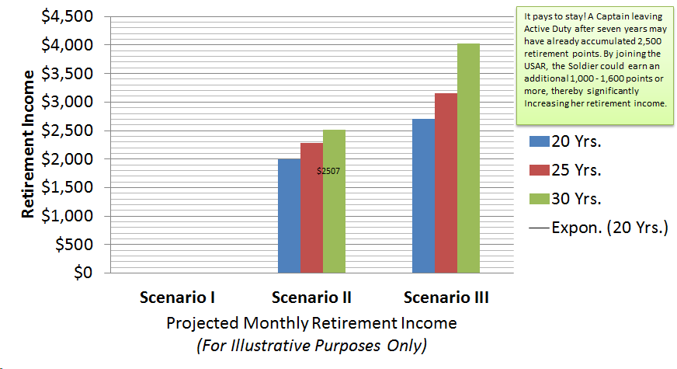

$2281

$1992

$0

If you are considering leaving Active Duty, you should strongly consider joining the RC, not only as a way to continue serving the country, and continuing to develop professionally, but also because IT PAYS TO STAY! For additional details, please contact the Judge Advocate Recruiting Office by phone (1-866-ARMY JAG (866-276-9524)), email ([army.jag.recruiting@us.army.mil](mailto:army.jag.recruiting@us.army.mil)) or on the Internet at www.jagcnet.army.mil/JARO. Alternatively, you may contact the Chief, Reserve Component Recruiting at (703) 693-0863 to learn more about opportunities near you.